# String Functions Assignment

**Mandatory**

1. **WAP to prompt and read a line of text with words separated by space. Tokenise and extract the words. Display them. Impement the following functions for this.**
   1. **int tokenise(char *arr); //tokenise and display tokens , return number of tokens to the caller**

**[Use strtok() to tokenise]**

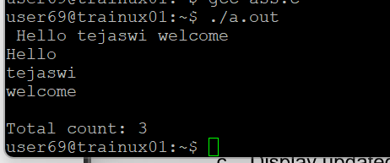

1. **Implement your own strncat() which shall concatenate n characters from src to dest.**

**char *strncat(char *dest, const char *src, size_t n)**

1. **WAP to** 
   1. **Search for and replace the vowel characters (upper and lower case) with “ay” in a word read from user. Consider a maximum word length of 40 characters.**
   2. **Identify the test inputs to be used**
   3. **Display updated string**



